Leetcode question
Palindrome Number - LeetCode
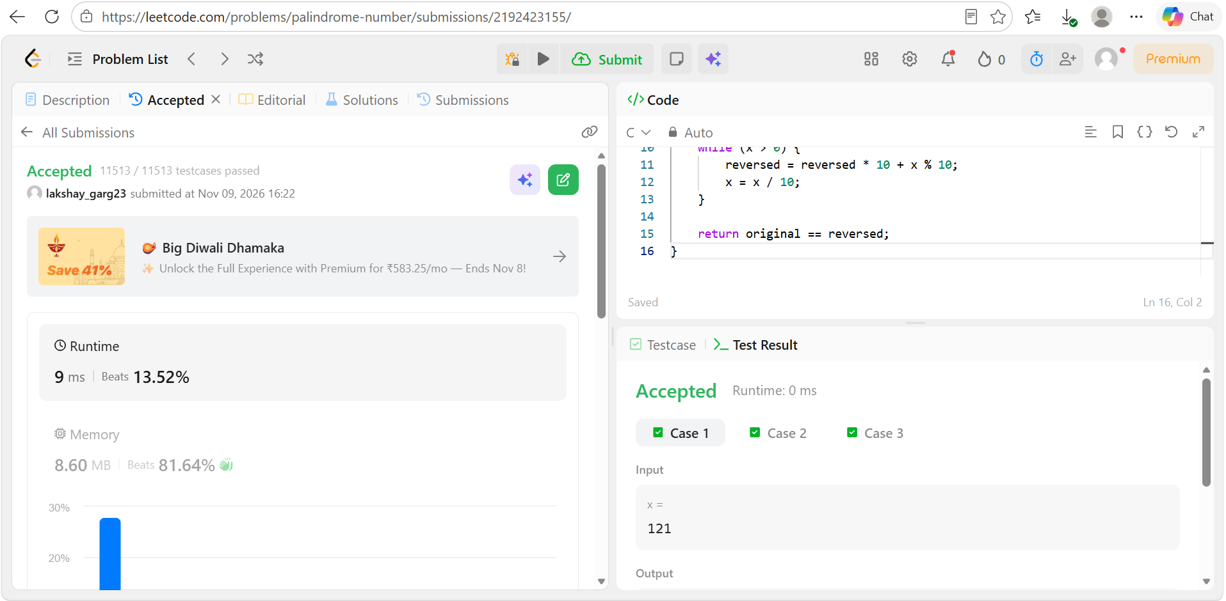
Code
#include <stdbool.h>

bool isPalindrome(int x) {
if (x < 0)
return false;

int original = x;
long long reversed = 0;

while (x > 0) {
reversed = reversed * 10 + x % 10;
x = x / 10;
}

return original == reversed;
}

